# Introducing HL7 FHIR

FHIR – **F**ast **H**ealth **I**nteroperable **R**esources ([hl7.org/fhir](http://www.hl7.org/fhir/)) – is a next generation standards framework created by HL7. FHIR applies lessons learned from HL7’s v2, v3 and CDA product lines while leveraging the latest web standards and applying a tight focus on implementability.

FHIR solutions are built from a set of modular components called “Resources”. These resources can easily be assembled into working systems that solve real world clinical and administrative problems at a fraction of the price of existing alternatives.

FHIR is suitable for use in a wide variety of contexts – from social media on mobile phones through to server communication in large institutional healthcare providers.

## Why FHIR is better

FHIR offers many improvements over existing standards:

* **Interoperability out-of-the-box** – base resources can be used without templates or constraints
* Transparently supports **messaging, services, document and RESTful** architectures – with full interoperability and ability to share profiles and templates across them
* Strong focus on **implementation** – fast and easy to implement (multiple developers have had simple interfaces working in a single day)
* Multiple **implementation libraries**, many **examples** available to kick-start development
* Specification is **free for use** with no restrictions
* **Evolutionary development** from HL7 v2 and CDA – standards can co-exist and leverage each other
* Leverages **Web standards** – XML, JSON, HTTP, Atom, OAuth, etc.
* Specifications are **concise** and can **easily by understood**, including by clinicians
* **Human-readable wire format** for developers
* **Backed by solid ontologies** and rigorous formal mapping for correctness

## Extensions

A central challenge for healthcare standards is how to handle variability caused by diverse health care processes. Over time, more fields and optionality are added to the specification, gradually adding cost and complexity to the resulting implementations. The alternative is relying on extensions. However, traditionally these have been associated with implementation problems too.

FHIR solves this challenge by defining a simple framework for extensions. All that is needed is a reference to the definition of the extension:

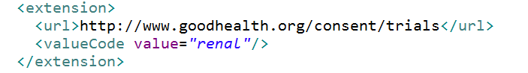

All systems, no matter how they are developed, can easily read these extensions and extension definitions can be retrieved using same framework as retrieving other resources.

## Example Resource: Patient

This simple example shows the two important parts of a resource: the standard defined data content and a human readable HTML presentation that is most useful with more complex clinical content.

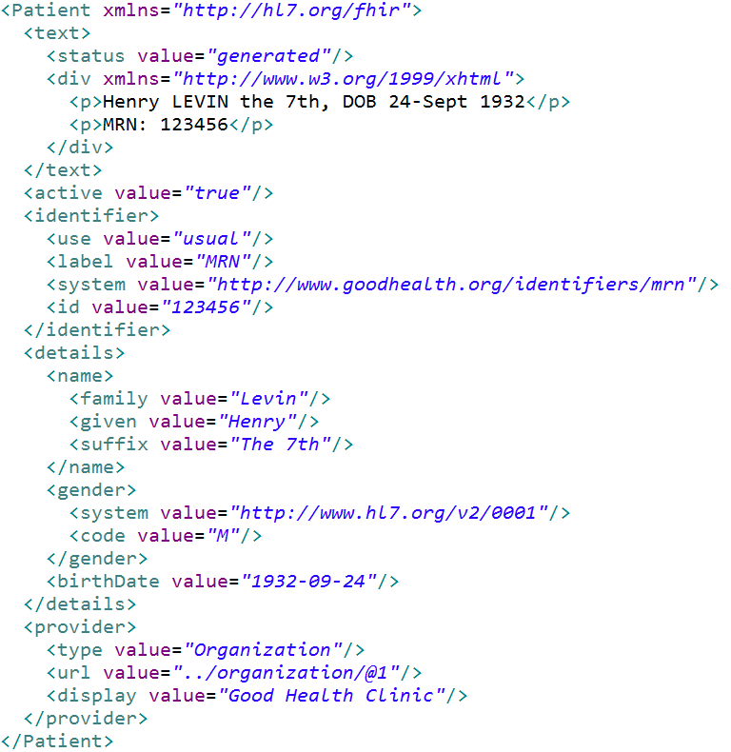

Standard Data   
Content:

* Status
* MRN
* Name
* Gender
* Date of Birth
* Provider

Human Readable

Summary

FHIR has resources for administrative concepts such as Patient, Provider, Organization and Device as well as a wide variety of clinical concepts covering Problems, Medications, Diagnostics, Care plans, financial concerns and more.

## The FHIR development process

FHIR is still undergoing development as an HL7 standard. By the end of 2013, FHIR should be available as a Draft Standard for Trial Use. After a period of trial use to bed the specification, HL7 will develop FHIR as a full normative specification, most likely through 2015.

Due to the many advantages FHIR offers, trial use is already beginning right now.

FHIR. [C:\workspace\projects\org.hl7.fhir\publish\flame16.png](http://hl7.org/fhir) <http://www.hl7.org/fhir/>. Follow us on #FHIR